***Practical 9***

Aryaman Gautam

J001

Installation of Raspberry Pi:

Step 1 — Download and Install Raspberry Pi Imager

The first step is to download the Raspberry Pi Imager from the official [Raspberry Pi website](https://www.raspberrypi.org/downloads/). This tool will allow you to choose an OS, have it downloaded automatically, and write it to the SD card of your choice.

**Step 2: Choose OS**

Several operating systems are available for selection within the Raspberry Pi Imager, but we will focus on Raspberry Pi OS.

There are 3 versions of Raspberry Pi OS available. We will briefly touch on each one but we will be using **Raspberry Pi OS (32-bit)**for this guide.

## **Step 3: Choose SD Card**

You’ll now need your SD card connected to your computer to copy over the OS you chose

**Step 4: Write to SD Card**

This step will write the selected OS to the SD card and run a verification that the copy was successful.

## **Step 5: Booting Your Raspberry Pi**

Insert your microSDHC card into your Raspberry Pi. Then, hook up your Raspberry Pi to power, keyboard, mouse, and monitor.

Step 6 :Configure Raspeberry Pi Username and Password

The next screen will prompt you to change your password. The default username is “pi” and the default password is “raspberry”

**Programming with GPIOZero/any other library**

1. Turn LED on when object is at proximity, off otherwise

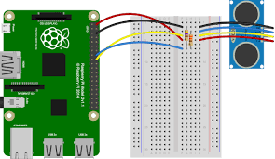

from gpiozero import DistanceSensor, LED

from signal import pause

sensor = DistanceSensor(4,17)

led = LED(5)

sensor.when_in_range = led.on()

sensor.when_out_of_range = led.off()

pause()

1. Turn LED on based on light intensity

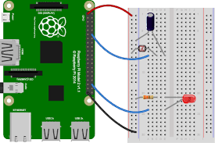

from gpiozero import LightSensor, PWMLED

from signal import pause

sensor = LightSensor(17)

led = PWMLED(4)

led.source=sensor

pause()

1. Create LED chaser

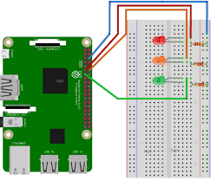

from gpiozero import LED

from time import sleep

red = LED(2)

amber = LED(3)

green = LED(4)

while True:

green.on()

amber.off()

red.off()

sleep(5)

green.off()

amber.on()

sleep(5)

amber.off()

red.on()

sleep(5)

red.off()

amber.on()

sleep(5)

amber.off()

green.on()

sleep(5)

1. When button is pressed open servo motor shaft

from gpiozero import Servo, Button

servo = Servo(17)

btn = Button(4)

while True:

servo.min()

btn.wait_for_press()

servo.max()

btn.wait_for_press()

1. Traffic signal in RPi



from gpiozero import TrafficLights

from time import sleep

lights = TrafficLights(2, 3, 4)

lights.green.on()

while True:

sleep(10)

lights.green.off()

lights.amber.on()

sleep(1)

lights.amber.off()

lights.red.on()

sleep(10)

lights.amber.on()

sleep(1)

lights.amber.off()

lights.green.on()

lights.red.off()

1. RGB LED controlled by three button, one for each color

from gpiozero import LED, Button

from signal import pause

buttonr = Button(2)

buttona = Button(3)

buttong= Button(4)

red = LED(5)

amber = LED(6)

green = LED(7)

buttonr.when_pressed = red.on()

buttonr.when_released = red.off()

buttona.when_pressed = amber.on()

buttona.when_released = amber.off()

buttong.when_pressed = green.on()

buttong.when_released = green.off()

pause()

1. Turn LED on if motion is detected

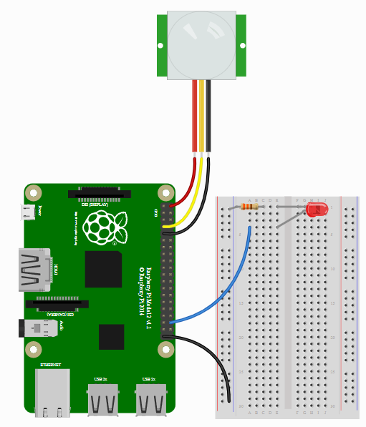

from gpiozero import MotionSensor, LED

from signal import pause

pir = MotionSensor(4)

led = LED(16)

pir.when_motion = led.on()

pir.when_no_motion = led.off()

pause()

1. Make robot go in a square

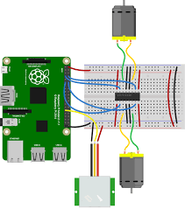

from gpiozero import Robot

robot = Robot(left=(1,2), right=(3,4))

while True:

robot.forward()

sleep(10)

robot.backward()

sleep(10)